Senegal

## Population Data

The data set shows the political stability estimate of the country each year.

## # A tibble: 23 x 5  
## country iso3c date population popCategory5  
## <chr> <chr> <dbl> <dbl> <chr>   
## 1 Senegal SEN 1996 8912861 small   
## 2 Senegal SEN 1997 9130877 small   
## 3 Senegal SEN 1998 9347774 small   
## 4 Senegal SEN 1999 9568722 small   
## 5 Senegal SEN 2000 9797734 small   
## 6 Senegal SEN 2001 10036104 small   
## 7 Senegal SEN 2002 10283699 small   
## 8 Senegal SEN 2003 10541467 small   
## 9 Senegal SEN 2004 10810083 small   
## 10 Senegal SEN 2005 11090116 small   
## 11 Senegal SEN 2006 11382268 small   
## 12 Senegal SEN 2007 11687080 small   
## 13 Senegal SEN 2008 12004701 small   
## 14 Senegal SEN 2009 12335084 small   
## 15 Senegal SEN 2010 12678148 small   
## 16 Senegal SEN 2011 13033809 small   
## 17 Senegal SEN 2012 13401991 small   
## 18 Senegal SEN 2013 13782420 small   
## 19 Senegal SEN 2014 14174731 small   
## 20 Senegal SEN 2015 14578459 small   
## 21 Senegal SEN 2016 14993528 small   
## 22 Senegal SEN 2017 15419381 small   
## 23 Senegal SEN 2018 15854360 small

# Population growth data

## # A tibble: 23 x 5  
## country iso3c date popGrowth popGrowthCat5   
## <chr> <chr> <dbl> <dbl> <chr>   
## 1 Senegal SEN 1996 2.53 high growth rate   
## 2 Senegal SEN 1997 2.42 moderate growth rate  
## 3 Senegal SEN 1998 2.35 moderate growth rate  
## 4 Senegal SEN 1999 2.34 moderate growth rate  
## 5 Senegal SEN 2000 2.37 moderate growth rate  
## 6 Senegal SEN 2001 2.40 moderate growth rate  
## 7 Senegal SEN 2002 2.44 moderate growth rate  
## 8 Senegal SEN 2003 2.48 moderate growth rate  
## 9 Senegal SEN 2004 2.52 high growth rate   
## 10 Senegal SEN 2005 2.56 high growth rate   
## 11 Senegal SEN 2006 2.60 high growth rate   
## 12 Senegal SEN 2007 2.64 high growth rate   
## 13 Senegal SEN 2008 2.68 high growth rate   
## 14 Senegal SEN 2009 2.71 high growth rate   
## 15 Senegal SEN 2010 2.74 high growth rate   
## 16 Senegal SEN 2011 2.77 high growth rate   
## 17 Senegal SEN 2012 2.79 high growth rate   
## 18 Senegal SEN 2013 2.80 high growth rate   
## 19 Senegal SEN 2014 2.81 high growth rate   
## 20 Senegal SEN 2015 2.81 high growth rate   
## 21 Senegal SEN 2016 2.81 high growth rate   
## 22 Senegal SEN 2017 2.80 high growth rate   
## 23 Senegal SEN 2018 2.78 high growth rate

## Population trend

The plot shows the population trend of the country.

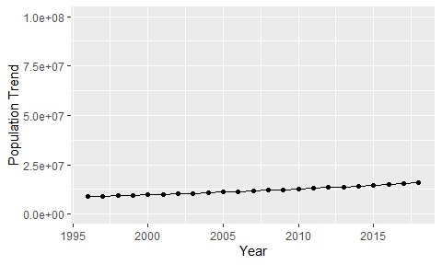

Political Stability Trend

# Population growth trend

The plot shows the population growth rate trend of the country.

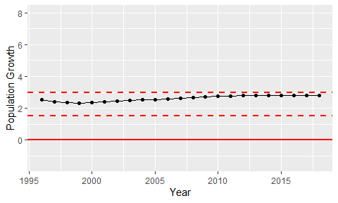

Population Growth Trend